Passover Fundraiser
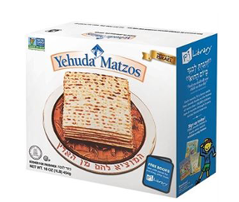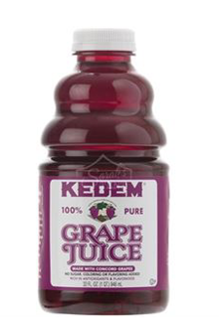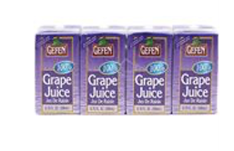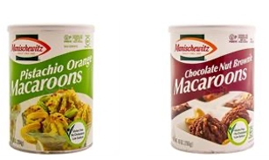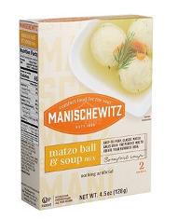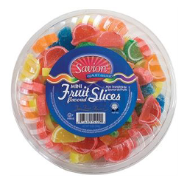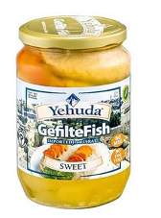
Let us take some of the stress out of Passover preparations.
Volunteers will shop for your selection of Passover food items.
Pick up will be at Temple Beth-El the week before Passover.
A donation to the Temple for this service would be appreciated.

Order Due: March 15,
Pick up dates: March 22-26

Name:______________________Email:_________________

Phone:______________________ Text

Item | Quantity | Price | Subtotal:
Box of Matzo (16 oz) |  | $2.00 | $_____________
5 lbs. Box of Matzo |  | $10.00 | $_____________
My Mini Matzah (2.8 oz) |  | $3.50 | $_____________
Shmurah Matzo (16 oz) |  | $8.00 | $_____________
Matzo Farfel (14 oz) |  | $4.00 | $_____________
Matzo Meal (12 oz) |  | $3.00 | $_____________
Matzo Ball soup mix |  | $2.50 | $_____________
Kosher for Passover cake mix  Coffee Cake  Extra Moist Coffee Cake  Carrot Cake  Marble Cake  Honey Cake  Gluten free Chocolate  Extra Moist Chocolate | _____  _____  _____  _____  _____  _____  _____ | $5.00 | $_____________  $_____________  $_____________  $_____________  $_____________  $_____________  $_____________
Gefilte Fish |  | $5.00 | $_____________
32 oz Bottle Grape Juice |  | $3.00 | $_____________
4 pack Grape Juice Boxes |  | $3.00 | $_____________
Macaroons  Coconut  Chocolate  Chocolate nut brownie  Pistachio orange | _____  _____  _____  _____ | $5.00 | $_____________  $_____________  $_____________  $_____________
Fruit Slices |  | $5.50 | $_____________
Subtotal |  |  | $_____________
Donation |  | Suggested $10 | $_____________
 |  | Total: | $_____________

*Brand and Flavor may vary depending on availability.

