Gourmet Chocolate treats and gifts for Hanukkah from Veruca Chocolates available for pre-order. Orders and payment must be submitted by November 25th to the Temple Beth-El office. Order pick up will be the week of December 7,8, and 9th. Local Drop-off Delivery available for $5.

Name:_________________________________Phone:_________________________Email:_________________________________________

Address for Delivery: _________________________________________ City:________________________ Zip:_________________

Item |  | Price | Quantity | Total
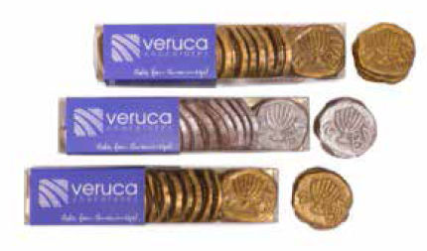 | Gelt for Grown-Ups™  Veruca Chocolates’ handcrafted, Kosher* Gelt for Grown-Ups® is a modern and delicious alternative to the standard foil-wrapped Hanukkah gelt, and is perfect for Hanukkah gifts and dreidel games, B’nai Mitzvah favors, or anytime you crave a perfect sweet indulgence. Each chocolate coin is molded to replicate an actual Judean coin dating back to the 4th decade BCE, and is airbrushed in gold or silver (no foil!). NEW smaller size box now available!  All of our luxury chocolate Gelt for Grown-Ups™ are handmade in Chicago, Illinois and are certified Kosher by the Chicago Rabbinical Council.  Dark Chocolate with Sea Salt and Dark Chocolate with Cocoa Nibs:  Allergens: contains soy  Gluten free, Nut free, Vegan  Kosher Dairy  Consume within: 6 months  Milk Chocolate:  Allergens: contains soy, dairy  Gluten free, Nut free  Kosher Dairy  Consume within: 6 months | $15.00  (4 oz box) | Dark Chocolate w/ Sea salt ______  Dark Chocolate with Cocoa nibs ______  Milk Chocolate _______ | $______  $______  $______
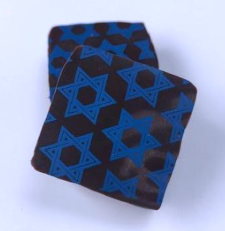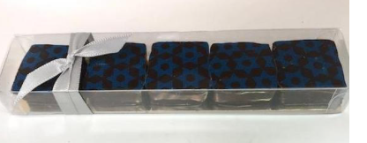 | Star of David Sea Salt Caramels  Five of our acclaimed signature Sea Salt Caramels topped with a Star of David design. Each gourmet Sea Salt Caramel is made with hand-flaked salt from the Maldon Coast of England and enrobed in 64% dark chocolate. Our Sea Salt Caramels are widely beloved and make a wonderful gourmet gift.  Allergens: contains soy, milk  Gluten free, Nut free  Kosher Dairy  Consume within: 3 months | $9.50 | 5 piece box ____ | $_____
 |  |  | Subtotal | $
 |  |  | Tax 7.75% | $
 |  |  | Local Delivery $5 per order | $
Images and descriptions are property of for additional information on products visit https://www.verucachocolates.com |  |  | Total Due | $

