Gourmet Chocolate treats and gifts for Hanukkah from Veruca Chocolates available soon in the Temple Beth-El Gift Shop. Pre-order for a 10% discount off retail prices. Pre-orders and payment must be submitted by November 25th to the Temple Beth-El office or Gift Shop. Order pick up will be the week of December 8th.
Name:_________________________________Phone:_________________________Email:_________________________________________
Item |  | Price | Quantity | Total
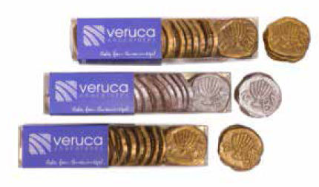 | Gelt for Grown-Ups™  Veruca Chocolates’ handcrafted, Kosher* Gelt for Grown-Ups® is a modern and delicious alternative to the standard foil-wrapped Hanukkah gelt, and is perfect for Hanukkah gifts and dreidel games, B’nai Mitzvah favors, or anytime you crave a perfect sweet indulgence. Each chocolate coin is molded to replicate an actual Judean coin dating back to the 4th decade BCE, and is airbrushed in gold or silver (no foil!). NEW smaller size box now available!  All of our luxury chocolate Gelt for Grown-Ups™ are handmade in Chicago, Illinois and are certified Kosher by the Chicago Rabbinical Council.  Dark Chocolate with Sea Salt and Dark Chocolate with Cocoa Nibs:  Allergens: contains soy  Gluten free, Nut free, Vegan  Kosher Dairy  Consume within: 6 months  Milk Chocolate:  Allergens: contains soy, dairy  Gluten free, Nut free  Kosher Dairy  Consume within: 6 months | $14.99  $13.49 (4 oz box) | Dark Chocolate w/ Sea salt ______  Dark Chocolate with Cocoa nibs ______  Milk Chocolate _______ | $______  $______  $______
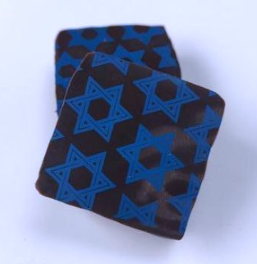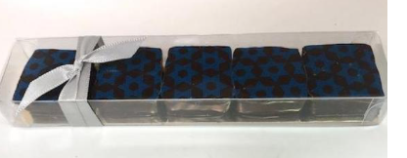 | Star of David Sea Salt Caramels  Five of our acclaimed signature Sea Salt Caramels topped with a Star of David design. Each gourmet Sea Salt Caramel is made with hand-flaked salt from the Maldon Coast of England and enrobed in 64% dark chocolate. Our Sea Salt Caramels are widely beloved and make a wonderful gourmet gift.  Allergens: contains soy, milk  Gluten free, Nut free  Kosher Dairy  Consume within: 3 months | $9.25  $8.33 | 5 piece box ____ | $_____
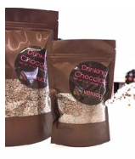 | Gourmet Drinking Chocolate  Hot chocolate the way it is meant to be: just ground chocolate, for a smoother texture. Enjoy our custom blend of our favorite milk and dark chocolates - just add milk, water or cream and enjoy a steaming cup of hot chocolate!  Allergens: contains soy, milk  Gluten free, Nut free  Kosher Dairy  Consume within: 12 months | $6.00  $5.40  (6oz)  $12.00  $10.80 (14 oz) | 6oz. ______  14 oz.______ | $_____  $_____
 |  |  | Subtotal | $
 |  |  | Tax 8.25% | $
Images and descriptions are property of for additional information on products visit https://www.verucachocolates.com |  |  | Total Due | $

